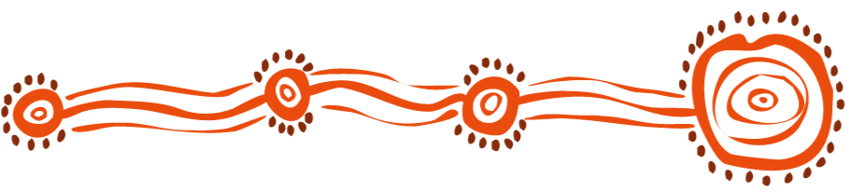
GALCAC Speak, Read and Write Goldfields Languages Course Registration 2022
Return to info@wangka.com.au One form per person attending
$30 inc GST per person

Name of participant:

Business name:

Email:

Phone:

Postal address:

Group booking- number of people:

Course dates for 2022: (tick the course you’ll attend at the GALCAC office in Boulder)

☐ Friday 18th Feb 2022 10am – 12pm  ☐ Friday 11th March 2022 10am – 12pm  ☐ Friday 8th April 2022 10am – 12pm  ☐ Friday 6th May 2022 10am – 12pm  ☐ Friday 10th June 2022 10am – 12pm | ☐ Friday 22nd July 2022 10am – 12pm  ☐ Friday 12th August 2022 10am – 12pm  ☐ Friday 9th Sept 2022 10am – 12pm  ☐ Friday 7th October 2022 10am – 12pm  ☐ Friday 4th November 2022 10am – 12pm

Any special seating or needs (GALCAC office is wheelchair accessible, no steps or stairs)

Do you require a quote or invoice? Please provide an email addresss to send it to.

☐ Yes send the quote to

Att:

Email:

☐ Yes send the invoice to

Att:

Email:

☐ No quote or invoice needed , I will pay cash before the course date

Your Purchase order number:

Payment Option 1: Payment by EFT to
Bank: Commonwealth Bank
Account name: Goldfields Aboriginal Language Centre Aboriginal Corporation
BSB: 066-514 Account: 1064 7850
Payment Option 2: payment by credit card over the phone
Payment Option 3: payment in person at the Language Centre, 2 Burt St, Boulder by EFTPOS or cash
Payment Option 4: payment by cheque through post or in person

Payment or purchase order required before the course date to secure a place. Cancellations must be 24 hours before course start or 100% fee is payable.

